**Pizza Sales Analysis**

**Table of Contents**

* Problem Statement
* Dataset Overview
* Data Analysis using MySQL
* Dashboard/Report using Power BI
* Key Insights and Findings
* Challenges Faced
* Tools and Software

**Problem Statement**

The objective of this project is to analyze pizza sales data to identify key sales trends, customer preferences, and inventory management. The primary goals include :

* Understanding revenue trends over time.
* Identifying the best-selling and least-selling pizza types.
* Analyzing peak sales hour and order patterns.
* Evaluating sales performance by pizza size and category.

**Dataset Overview**

The dataset used for this includes transactional data from a pizza restaurant containing :

* order_datails_id
* order_id
* pizza_id
* quantity
* order_date
* order_time
* unit_price
* total_price
* pizza_size
* pizza_category
* pizza_ingredients
* pizza_name

This dataset allows us to derive meaningful insights related to sales trends, demand forecasting, and customer behavior.

**Data Analysis using MySQL**

**Steps Involved :**

1. Importing and cleaning the dataset.
2. Exploring key sales metrics such as revenue, best-selling pizzas, and peak sales hours.
3. Identifying customer preferences and demand patterns.
4. Generating SQL queries to extract insights :

* Total revenue.
* Best and worst-performing pizzas.
* Average order value.
* Peak order times.
* Sales contribution by pizza category.

SQL Queries :

--Total Quanity

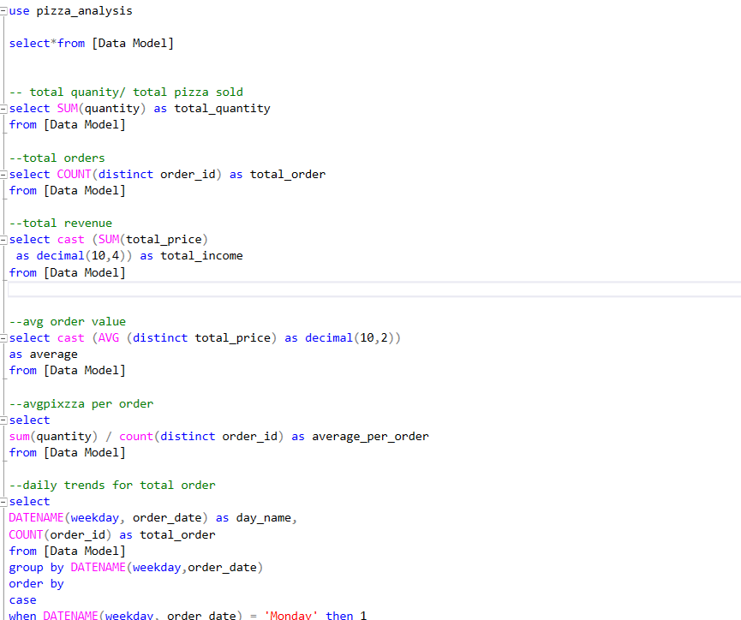

Result :

--Total Order



Result :

--Total Revenue

Result :

--Average order value

Result :

--Average pizza per order

Result :

--Daily Trends for Total Orders

Result :

--Monthly Trends for Orders

Result :

--Percentage Sale by Pizza Category

Result :

--Percentage Sale by Pizza Size

Result :

--Total Sold by Category

Result :

--Top 5 Pizza by Revenue

Result :

--Bottom 5 Pizza by Revenue

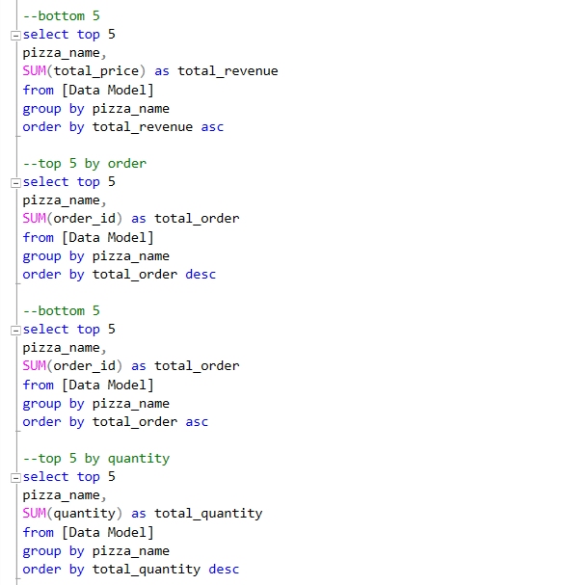

Result :

--Top 5 by Orders

Result :

--Bottom 5 by Orders

Result :

--Top 5 by Quantity

Result :

--Bottom 5 by Quantity

Result :

**Dashboard/Report using Power BI**

A dynamic Power BI dashboard is created to visualize :

Pizza Sale Analysis

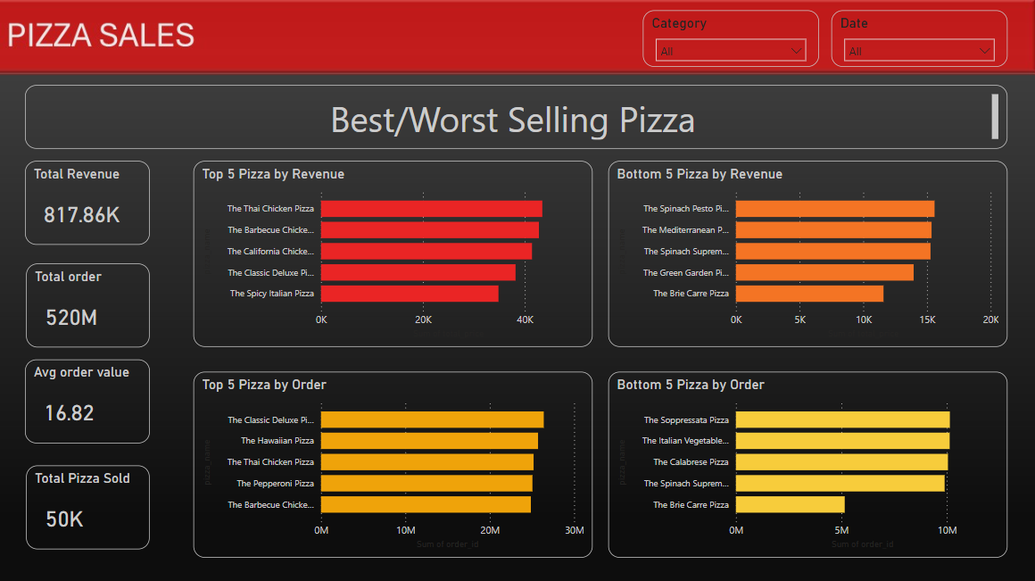

Best/Worst Selling Pizza

**Key Features of the Dashboard :**

* Interactive filters for data range selection.
* Drill-down options for specific categories.
* Visual representation of revenue.

**Challenges Faced**

* **Data Cleaning Issues:** Handling missing timestamps and duplicate entries required preprocessing before analysis.
* **SQL Query Optimization:** Running large queries on the dataset took longer than expected, requiring indexing and optimization.
* **Dashboard Performance:** Ensuring the Power BI dashboard loads quickly with large datasets was a challenges that required optimizing extracts.

**Tools and Software**

* **Excel –** Data Cleaning.
* **MySQL –** Data extraction and analysis.
* **Power BI –** Dashboard/report visualization.